Analysis of Home Mortgage Data
Justin Sharber

Executive Summary Outline
This project analyzes loan acceptance rates in publicly available home mortgage data, with two goals.
- Predict loan acceptances based on the available data. The result is a mediocre predictive accuracy of 70%.
- Analyze loan acceptance rates for unfair discrimination. A discriminatory effect is found, but it is tiny.

Predicting Loan Acceptance
The Home Mortgage Disclosure Act of 1975 requires financial institutions to report information about loan applications. This data allows us to determine whether loan practices are serving people well, as well as whether any unfair discrimination exists in the industry. The goal of this project is to determine which factors are relevant to loan acceptance. To achieve this goal, the project seeks to predict loan acceptance rates. The result is that only half of the available features are necessary to exhaust the predictive power of the dataset.
The dataset is substantial, with almost 440,000 complete records out of a total 500,000. It contains four main categories of data, summarized below.
Property Location | Location of the property, including codes for metropolitan area, county, and state. Some of this data was incomplete.
Loan Information | Including the lender, loan amount, loan type, the type of housing, the purpose of the loan (ex: home improvement), occupancy, and whether preapproval was requested.
Applicant Information | Including the applicant’s income, ethnicity (vis whether Hispanic / Latino), race, sex, and whether there was a co-applicant.
Census Information | Information about the tract where the loan request was made: population, minority percentage of the population, FFIEC median family income for the tract’s metropolitan area (Metropolitan Statistical Area / Metropolitan Division, MSA/MD), and several other statistics.
Summary of features in the dataset.
To get a sense of the relative importance of different features, logistic regressions were run independently on each. Many features had weak predictive power.
The predictive accuracy of each feature is shown below, split into two groups. Later, the accuracy of the first group, “Feature Set 1,” will be compared to the whole.
Feature Set 1 | Acc. |  | Feature Set 2 | Acc.
lender | 0.66 |  | property_type | 0.54
loan_purpose | 0.61 |  | state_code | 0.54
loan_amount | 0.58 |  | applicant_sex | 0.53
applicant_income | 0.58 |  | preapproval | 0.53
applicant_race | 0.57 |  | county_code | 0.53
applicant_ethnicity | 0.55 |  | loan_type | 0.52
co_applicant | 0.55 |  | occupancy | 0.52
msa_md | 0.55 |  | population | 0.52
minority_population_pct | 0.55 |  | ffiecmedian_family_income | 0.52
tract_to_msa_md_income_pct | 0.55 |  | number_of_owner-occupied_units | 0.52
 |  |  | number_of_1_to_4_family_units | 0.52
Predictive power of features, taken independently.

It may come as a surprise that the individual lender was the most predictive feature in the data. Several other features with comparatively high predictive accuracies were the amount of the requested loan, the applicant’s income, and whether there was a co-applicant.
The importance of the lender suggests that the loan approval process is fairly subjective. This signals a major theme of the project: there is a high degree of variation (or “randomness”) in loan approvals. It may be that loan officers may rely on their own subjective impressions of applicants in making a decision. But there may be other reasons for the variation. For example, different lenders may have different thresholds for risk, making some roundly more likely to approve a loan.
Unfortunately, applicant race appears to have higher predictive power as well. This suggests that there may be unfair discrimination in the process. But a definitive conclusion cannot yet be drawn. The second part of this report will examine that possibility.

Categorical Features
The categorical features in this dataset divide into two groups: those with a small number of categories (less than 10, call these “small categoricals”), and those with a large number of categories (ranging up to thousands, call these “big categoricals”).
Loan acceptance rates by each category of the small categoricals are given below. The features with greater differences in acceptance rates correspond to greater degrees of independent predictive accuracy.
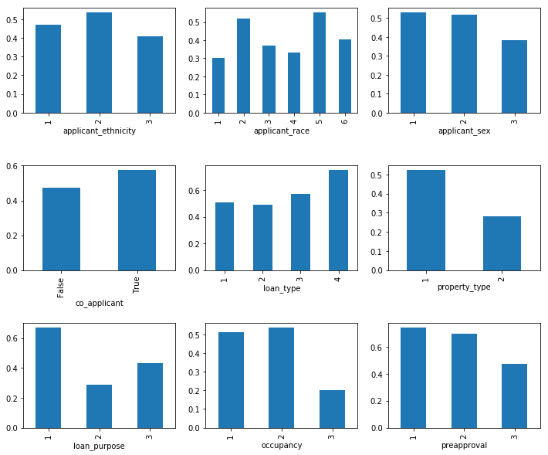
Loan acceptance rates by category.
Categories with greater differences in acceptance rates yield greater predictive accuracy. “Occupancy” (plot at bottom-center) has the least difference, and a predictive accuracy of only 0.52.

Categorical Features with Many Values
“Big categoricals” had too many categories to make for efficient predictive models, but they contained valuable information. The initial category counts are as follows:
Column | Count
msa_md | 409
state_code | 53
county_code | 318
lender | 6111
Big categoricals: category counts.
Feature engineering was performed on these features to find an efficient way to use these categories. Categories were grouped by their acceptance rates, in steps of 10% (as percentage points). If a category had too few data to get a reliable estimate of acceptance rate (a threshold at 50 was used), it was treated as unknown and grouped as such. The resulting loan acceptance rates are as follows. (Note, the category labels will be redundant, since the groups are just the acceptance rates.)
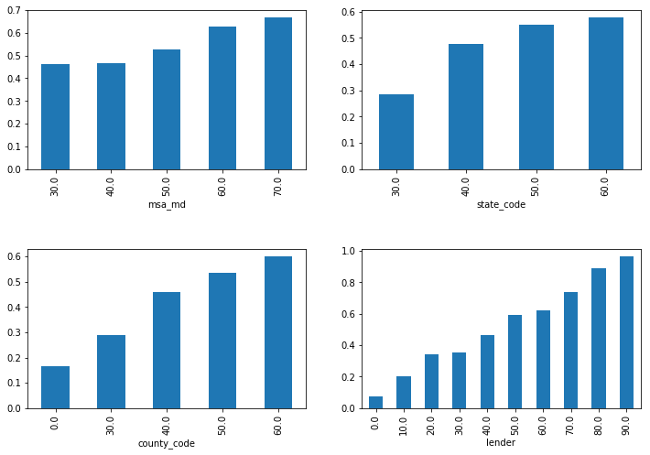
Binned big categorical features
“Lender” showed incredible variation, with some lenders accepting loan applications less than 10% of the time, and others accepting loans over 90% of the time. This variation corresponded to the highest independent predictive accuracy of 0.66.

Numeric Features
There is little to say about the numeric features. They exhibit few colinearities. The lack of colinearity could be a major advantage … if the features were more predictive independently. But in this case, the variation in the data is mostly noise.
Furthermore, as the label is categorical, there is no comparison to make with numeric features, and no work to be done in terms of transformations.
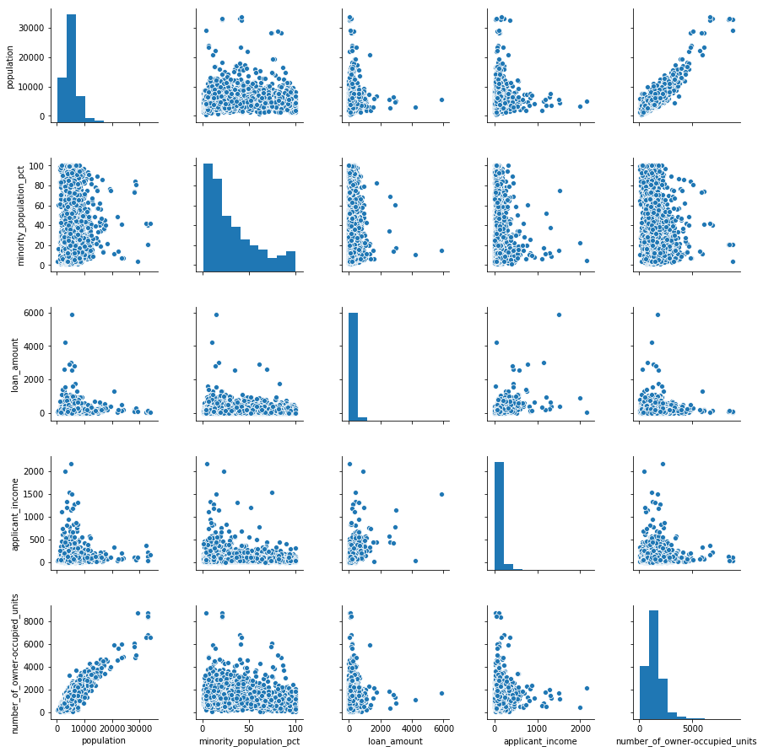
Selected numeric columns, sampled, plotted against each other in scatter plot. The label is categorical and not shown.

Modeling and Prediction
In search of the best model, multiple algorithms were tried. The neural network was the top performing algorithm. This model had two latent layers with 30 nodes each. The model also had the advantage of a large training set (over 320,000 data). However, it only achieved 70% accuracy on test data.
This result provides substantial support for the conclusion that there is a high degree of noise in loan acceptances. It looks that loan acceptances cannot be predicted to a high degree of accuracy.
Basic logistic regression was also tried. This model achieved a 69% accuracy on the test data, only 1 percentage point lower than the neural network. Logistic regression is the most basic classification model, separating the data based on a simple weighted sum of the features. The neural network model used is substantially more complex. The fact that the neural network barely outperformed logistic regression adds support for the conclusion that loan acceptances cannot be predicted with high accuracy.
The results for all models tried are below. All fell within a narrow window of about 1.5 percentage points.
Model | Accuracy
Logistic Regression | 69.1
Decision Tree (max depth = 12) | 69.4
Random Forest (40 classifiers) | 69.0
Support Vector Machines | 69.1
AdaBoost | 69.6
Neural Network (Hidden layers: 30, 30) | 70.6
Comparison of model accuracy on the small set of selected features vs. all features. Using all features yielded a tiny improvement.

Feature Selection
Recall that logistic regressions were run on each feature to see its independent predictive power. Test accuracy ranged from 0.66 to 0.52, with a fairly smooth distribution between 0.58 and 0.52.
Since the dataset was balanced, random guessing would result in an accuracy of 0.50. So an accuracy of only 0.52 is low indeed. This raised the question of how much predictive accuracy could be preserved with a subset of the features. The advantage of early feature selection is efficient processing and improved generalizability without the need for regularization. Could a chunk of the features be discarded, without real cost of predictive accuracy?
A criterion of 55% seemed a promising choice as a threshold. Features that scored an independent predictive accuracy of 0.55 or higher were selected. The criterion cut the feature set in half. At the risk of repetition, the feature accuracies are shown below.
Selected Features | Acc. |  | Rejected Features | Acc.
lender | 0.66 |  | property_type | 0.54
loan_purpose | 0.61 |  | state_code | 0.54
loan_amount | 0.58 |  | applicant_sex | 0.53
applicant_income | 0.58 |  | preapproval | 0.53
applicant_race | 0.57 |  | county_code | 0.53
applicant_ethnicity | 0.55 |  | loan_type | 0.52
co_applicant | 0.55 |  | occupancy | 0.52
msa_md | 0.55 |  | population | 0.52
minority_population_pct | 0.55 |  | ffiecmedian_family_income | 0.52
tract_to_msa_md_income_pct | 0.55 |  | number_of_owner-occupied_units | 0.52
 |  |  | number_of_1_to_4_family_units | 0.52
Features in the dataset were tested with independent logistic regressions; their accuracy scores are shown here. Features with an accuracy of 0.55 and up were selected.

Using just the significant features gave nearly the same result as using the whole set. This suggests that the significant features did contain the majority of the predictive power in the dataset. A tiny predictive improvement is gained by including the rest of the features.
Model | Selected Features | All Features
Logistic Regression | 68.9 | 69.1
Decision Tree (max depth = 12) | 69.2 | 69.4
Random Forest (40 classifiers) | 67.6 | 69.0
Support Vector Machines | 68.9 | 69.1
AdaBoost | 69.5 | 69.6
Neural Network (Hidden layers: 30, 30) | 70.3 | 70.6
Comparison of model accuracies on the set of selected features vs. all features. Using all features yielded a tiny improvement: 0.2-0.3 percentage points in most cases.

Comment on Predictability
What explains the low degree of predictability in the home mortgage system? Other systems are much more predictable. Graeme Malcolm has shown, for example, that classes of automobile prices—standard vs. premium, defined with a threshold price of $12,000—can be predicted to 95.5% accuracy with a much smaller dataset (216).
A major difference is that there is greater variation in loan applicants than there is in cars. Cars are made to be homogeneous by model, but loan applicants are not factory made. Cars may even be designed with a specific price point in mind, so designers may put some thought into calibrating features with price as price-signals. Loan applicants, as it were, “come as they are.”
The loan application process is intensive and individualized, whereas new cars of the same make are treated as equivalent by buyers. In the loan application process, an underwriter goes through the applicant’s financial information in detail, looking for any potential problem with a loan. This process means that many factors will be considered that outstrip the data recorded here. Different lenders may have drastically different attitudes toward risk, adding to the variation in the data for loan applicants. (As noted earlier, lenders showed a surprising degree of variation in acceptance rates.) In addition, the extensive, individualized review involved in the loan application process likely introduces opportunity for subjectivity.
In short, there are major differences between these two systems. Thus, the low predictability of loan rates makes some sense. But the variation and potential for subjectivity involved raises an important question: does the loan acceptance system involve unfair discrimination?

Evaluating Discrimination
The stated purpose of the HMDA is to see whether discrimination is occurring in the lending industry for housing. Here “discrimination” means unfair discrimination, viz. that based on race, ethnicity, or sex.
In reviewing the data, we noted that both applicant race and ethnicity had notable predictive accuracy as independent features. In addition, applicant sex gives some degree of predictive power as well.
Feature | Acc.
applicant_race | 0.57
applicant_ethnicity | 0.55
applicant_sex | 0.53

This looks damning. If we can predict loan acceptance based on unfair features such as race, then discrimination is occurring, right? Not necessarily. It may be that loan officers are making judgments on perfectly legitimate features that correlate with unfair ones, and that the decisions are not discriminatory after all. Principally, race is known to correlate with socio-economic status (SES), which is a legitimate factor in offering a loan. Thus a fair loan officer, one that only makes decisions based on legitimate factors, will accept loan applications at differential rates with regard to race.
Thus the problem of detecting discrimination is more difficult than that of simply determining a stastitical difference. The basic statistical analysis of categorical systems is to look for a statistically significant difference between two groups using a chi-squared test. Here, the chi-squared test would surely determine a difference in loan acceptance rates between racial categories, but this would not determine that discrimination is occuring.
To be clear on this situation, let us make a couple of side notes. First, these predictive accuracies basically prove that there is something unfair in our society. Nobody is saying, for example, that it is good or fair for SES to correlate with race on the broad societal scale. But this point is beyond our scope. The project here is to look at the decision-making of loan officers.
Second, based on objective data, it is only possible to see whether loan officers are making decisions based on unfair features. It cannot show us the inner thoughts and attitudes of loan officers. Uncovering personal prejudice requires something like a psychological test. This is also beyond our scope.
Third, certain kinds of features can serve as proxies for discrimination. In this context, a “proxy” is a feature that correlates with an unfair feature, and can be used as a veiled method for discriminating. For example, an applicant’s hometown, or by extension county, is somewhat predictive of their race, and has no apparent value in determining whether an applicant should receive a loan. So one must have a plan for potential proxy features.
These points guide the method of this project. The author makes two main assumptions.

Assumptions
- Loan officers take full advantage of all non-discriminatory features in making decisions. (This assumption avoids the pitfall of delivering a bad verdict too quickly.)
- The role of a feature in the decision-making process is reflected in the predictive power of that feature.
These assumptions are consistent with a step-wise comparison of predictive power. The features are divided into three categories: fair features, unfair features, and potential proxies. First, a predictive model will be trained on the predictive features, its predictive accuracy noted. Given our assumptions, the degree of predictive accuracy in the first set is considered legitimate, accounted for by fair features. Second, the unfair features are included and another predictive model (of the same family) is trained. If this second model is more predictive than the first, unfair discrimination would explain the additional predictive power. But if the second model is no more (or barely more) predictive than the first, discrimination is counted non-existent or negligible (respectively). The last set of features, the proxies, are left out completely. The goal at this point is not to achieve maximal predictive power, so the potential predictive power that these features offer is not important. The general stepwise approach follows Espenshade and others in detecting discrimination in admissions to elite universities.
Basic logistic regression is chosen as the predictive model. One reason is the relative success of logistic regression in the first part of this project, scoring just 1 percentage point lower than the neural network. The other reason is that Espenshade’s group used logistic regression for their paper.
In review, here is the method for detecting discrimination.

Method
- Train a logistic regression model on fair features, noting its predictive accuracy.
- Combine fair features and unfair features, and train another logistic regression model on this set.
- If the second set out-predicts the first by more than 0.5 percentage points, conclude that loan officers are discriminating to a significant degree.
The features are segregated as follows.
Unfair Features | Proxy Features | Fair Features
applicant_ethnicity  applicant_sex  applicant_race | minority_population_pct  msa-md  county_code  state_code | All other features.

Results
While the unfair features do represent additional predictive accuracy, the marginal boost is tiny: 0.2 percentage points. It would be nice if the extra accuracy could be waved off as pure error. Since the dataset is quite large (the training set size is about 330,000), and since accuracy was judged on test data, it indicates a real phenomenon.
Logistic Regression, Only Fair Features | 68.6%
Logistic Regression, Fair & Unfair | 68.8%
Difference (percentage points) | 0.2

The predictive advantage falls below the threshold set. Thus the relatively happy conclusion is that discrimination in home mortgages is not significant.

Conclusion
This concludes the analysis of home mortgage data. The first part showed that loan acceptances are difficult to predict from broad, objective data. Loan applicants are scrutinized on an individual basis, and lenders differ dramatically in acceptance rates. The second part analyzed potential discrimination. Initial predictive data was consistent with widespread discrimination. But further analysis showed that while discrimination does occur, it is rare.

Malcolm, Graeme. “Analysis of Automobile Prices.” (Online).
Psychology’s mainstay test for detecting internal attitudes of prejudice is the Implicit-Association Test. A test like this would be required to determine how loan officers feel about different groups, which is a less available question than whether their decisions show discrimination. However, the validity of the Implicit-Association Test has recently been called into question. See "Can We Really Measure Implicit Bias? Maybe Not."
Espenshade et al. “Admission Preferences for Minority Students, Athletes, and Legacies at Elite Universities.” Social Science Quarterly, Volume 85, Number 5, December 2004. Online.

